Cybersecurity Analyst Internship
Task Report

[samfelix15@gmail.com]
Task No: [16- Incidence Response Simulation]

Copyright © 2024 EncryptEdge Labs. All rights reserved
Credit: Offensive Security

Table of Contents
1.0 EncryptEdge Labs Internship Task Report 2
1.1 Introduction 3
1.2 Objective 4
1.3 Requirements 5
2.0 High-Level Summary 8
2.1 Recommendations 9
2.2 Risk exposure over time 9
3.0 Report - Methodologies 10
3.1 Information Gathering 11
4.0 Additionals Item 12
4.2 Screenshots X
1.0 EncryptEdge Labs Internship Task Report
1.1 Introduction
Incident response refers to a systematic approach to managing and addressing the aftermath of a security breach, accident, or disaster. Its primary goal is to minimize damage, reduce recovery time and costs, and mitigate the impact on an organization's operations and reputation. A well-structured incident response plan enables organizations to respond effectively, ensuring business continuity and limiting potential losses.
Incident response (IR) has its roots in the early days of computer security, but it wasn't until the 1990s and 2000s that IR started to gain prominence as a critical component of cybersecurity. Here's a brief overview
Early Beginning: IR concepts date back to the 1980s, but it wasn't until the 1990s that organizations began to formalize IR processes. The Computer Emergency Response Team (CERT) was established in 1988 at Carnegie Mellon University, marking one of the first major steps towards organized IR.
2000s: IR Gains Prominence: As cyber threats escalated, IR became a vital part of cybersecurity strategies. The National Institute of Standards and Technology (NIST) published its Special Publication 800-61, "Computer Security Incident Handling Guide," in 2004, providing guidelines for IR.
2010s: Frameworks and Regulations: IR frameworks like NIST's Cybersecurity Framework (2014) and regulations like the General Data Protection Regulation (GDPR, 2016) and the Cybersecurity and Infrastructure Security Agency (CISA) guidelines further solidified IR's importance.
Present Day: Critical Component: IR is now a cornerstone of cybersecurity, with organizations prioritizing IR plans, training, and technologies to detect, respond to, and mitigate cyber threats.
Key milestones that highlight IR's growing importance include
IST Cybersecurity Framework (2014) : Provides guidelines for organizations to manage and reduce cybersecurity risk.
Increasing Cyber Threat: Rising threats like ransomware and phishing attacks have made IR a critical defense strategy.
Regulatory Compliance: IR is essential for meeting regulatory requirements and avoiding penalties.
Today, IR is a crucial aspect of cybersecurity, enabling organizations to respond swiftly and effectively to security incidents, minimize damage, and ensure business continuity.
Incident response simulation is a critical component of cybersecurity that involves simulating security incidents to test incident response capabilities. The purpose of incident response simulation is to identify areas for improvement and ensure that organizations are prepared to respond to security incidents.

1.2 Objective
The core goals and objectives of incident response include:
1. Minimizing Impact: Reducing the impact of security incidents on the organization, its assets, and its reputation.
2. Restoring Operations: Restoring normal operations as quickly as possible after a security incident.
3. Preventing Future Incident: Identifying and addressing the root causes of security incidents to prevent future occurrences.
4. Compliance: Ensuring compliance with regulatory requirements and industry standards for incident response.
Based on my report my main core objectives is to
Understand the importance of incident response planning in cybersecurity.
Learn the key components of an incident response plan.
Develop skills in creating and simulating a basic incident response plan.
Understand the significance of incident response in cybersecurity.
Learn about the critical elements of an incident response plan.

1.3 Requirements
The requirements for incident response simulation include:
1. Realistic Scenarios: Developing realistic scenarios that simulate actual security incidents, including phishing attacks, malware outbreaks, and unauthorized access attempts.
2. Comprehensive Planning: Developing comprehensive plans for incident response simulation, including objectives, cope, and timelines.
3. Trained Personnel: Ensuring that personnel involved in incident response simulation are trained and aware of their roles and responsibilities.
4. Effective Communication: Establishing effective communication protocols for incident response simulation, including notification procedures and contact information.
With reference to my report, I am required to,
Submit a summary report highlighting the importance of incident response in cybersecurity, including the core goals and objectives.
Provide a detailed breakdown of the key components of an incident response plan, with an explanation of each phase in the incident lifecycle.
Submit the developed incident response plan, including screenshots of the process and documentation of roles, communication protocols, and escalation paths.

Key Benefits of Incident Response
Proactive Threat Detection: IR systems can predict and prevent cyber threats before they materialize, thanks to advanced technologies like Artificial Intelligence and Machine Learning.
Quick Response and Mitigation: IR helps contain threats, preventing them from causing significant damage and reducing response time.
Requirements: Implementing IR systems is crucial for compliance with regulatory mandates, reducing the risk of non-compliance and associated penalties.
Improvement in Security Posture: IR systems enable continuous improvement of an organization's security stance through adaptive learning and updating capabilities
Reducing Downtime: Incident response helps organizations quickly respond to security incidents, reducing downtime and minimizing the impact on business operations.
Protecting Assets: Incident response helps protect organizational assets, including data, systems, and infrastructure, from security threats.
Maintaining Reputation: Incident response helps organizations maintain their reputation by demonstrating a proactive and effective response to security incidents.
Compliance: Incident response helps organizations comply with regulatory requirements ad industry standards, reducing the risk of fines and penalties.
Importance in Critical Infrastructure
Protecting Essential Services: IR is vital for protecting critical infrastructure sectors like healthcare, energy, transportation, and manufacturing, which are essential to a nation's security, economy, public health, and safety.
Preventing Devastating Impacts: Effective IR can prevent ransomware attacks from disrupting critical services, which can have far-reaching impacts on the economy, safety, and well-being
Best Practices
Integration with Existing Systems: IR systems can be integrated into existing security infrastructure, enhancing overall cybersecurity posture.
Continuous Learning and Adaptation: IR systems should employ machine learning algorithms to continually improve detection capabilities and response protocols.
Automation and Reporting: IR systems can automate incident response and generate comprehensive reports, providing valuable insights for improving cybersecurity strategies

Key Components of Incident Response
The key components of incident response include:
Preparation
Preparation involves developing and implementing incident response plans, policies, and procedures. This phase is critical in ensuring that organizations are ready to respond to security incidents.
Incident Response Plan: Developing a comprehensive incident response plan that outlines roles, responsibilities, and procedures.
Training and Awareness: Providing training and awareness programs for personnel to ensure they understand their roles and responsibilities in incident response.
Identification
Identification: involves detecting and reporting security incidents. This phase is critical in ensuring that organizations quickly identify and respond to security incidents.
Monitoring: Continuously monitoring systems, networks, and applications for security incidents.
Reporting: Establishing reporting mechanisms for personnel to report security incidents.
Containment
Containment involves taking steps to prevent the spread of security incidents and minimize damage. This phase is critical in ensuring that security incidents do not escalate and cause further damage.
Isolation: Isolating affected systems, networks, or applications to prevent the spread of security incidents.
Mitigation: Implementing mitigation measures to reduce the impact of security incidents.
Eradication involves removing the root cause of security incidents and restoring systems, networks, or applications to a normal state. This phase is critical in ensuring that security incidents are fully resolved.
Root Cause Analysis: Conducting root cause analysis to identify the cause of security incidents.
Removal: Removing the root cause of security incidents and restoring systems, networks, or applications.
Recovery
Recovery involves restoring normal operations and implementing measures to prevent future security incidents. This phase is critical in ensuring that organizations can quickly recover from security incidents.
Restoring systems, networks, or applications to a normal state.
Implementation: Implementing measures to prevent future security incidents.
Lessons Learned
Lessons learned involves reviewing and documenting security incidents to identify areas for improvement. This phase is critical in ensuring that organizations can learn from security incidents and improve their incident response capabilities.

2.0 High-Level Summary
Incident response simulation is a critical component of cybersecurity that involves simulating security incidents to test incident response capabilities. The purpose of incident response simulation is to identify areas for improvement and ensure that organizations are prepared to respond to security incidents. By testing incident response plans, policies, and procedures, organizations can improve their incident response capabilities and reduce the risk of security incidents
IR is essential for protecting critical infrastructure, preventing devastating impacts, and ensuring business continuity. Effective IR can prevent ransomware attacks, data breaches, and other security incidents from disrupting critical services, which can have far-reaching impacts on the economy, safety, and well-being. IR also helps organizations comply with regulatory requirements and industry standards, reducing the risk of non-compliance and associated penalties.
The benefits of IR include proactive threat detection, quick response and mitigation, improvement in security posture, and compliance with regulatory requirements. IR systems can employ advanced technologies like Artificial Intelligence and Machine Learning to predict and prevent cyber threats, contain threats, and automate incident response. By implementing IR, organizations can reduce the risk of security incidents, minimize damage, and ensure business continuity

2.1 Recommendations
Based on the importance of incident response simulation, the following recommendations are made:
1. Conduct Regular Simulations: Conducting regular incident response simulations to test incident response capabilities and identify areas for improvement.
2. Use Realistic Scenario: Using realistic scenarios that simulate actual security incidents to ensure that incident response capabilities are effective and efficient.
3. Provide Training and Awareness: Providing training and awareness programs for personnel involved in incident response simulation to ensure they understand their roles and responsibilities.
4.Continuously Improve: Continuously improving incident response capabilities by implementing best practices and addressing areas for improvement identified during incident response simulation.

2.2 Risk Exposure over Time
The risk exposure over time for incident response simulations is significant, as organizations that do not conduct regular incident response simulations may be exposed to various risks, including:
1. Inadequate Incident Response: Inadequate incident response capabilities may lead to delayed or ineffective response to security incidents, resulting in increased downtime and damage.
2. Non-Compliance: Non-compliance with regulatory requirements and industry standards for incident response may result in fines and penalties.
3. Reputation Damage: Failure to respond effectively to security incidents may damage an organization's reputation and erode customer trust.

3.0 Methodologies
The methodology for incident response simulation involves:
1. Scenario Development: Developing realistic scenarios that simulate actual security incidents.
2. Simulation Planning: Developing comprehensive plans for incident response simulation, including objectives, scope, and timelines.
3. Simulation Execution: Executing incident response simulation, including testing incident response plans, policies, and procedures.
4. Debriefing and Review: Conducting debriefing and review sessions to identify areas for improvement and document lessons learned.

3.1 Information Gathering
Information gathering for incident response simulation involves collecting and analyzing data related to security incidents, including:
1. Incident Data: Collecting and analyzing data related to security incidents, including incident type, impact, and response time.
2. Threat Intelligence: Collecting and analyzing threat intelligence data to identify potential security threats and vulnerabilities.
3. Incident Response Metrics: Collecting and analyzing incident response metrics, including response time, resolution rate, and customer satisfaction.
By gathering and analyzing this information, organizations can improve their incident response capabilities and reduce the risk of security incidents.

Based on my report,information was gathered via from Youtube ,cheat sheets, articles, journals provided to me by EncryptEdgeLabs. These may include,
Cheat Sheets or Notes:
Incident Response Plan Template – BlueVoyant
Incident Response Cheat Sheet – LinkedIn
GitHub Repositories:
Sample Incident Response Plans
Incident Response Tools

Articles:
What is an Incident Response Plan? – UpGuard
How to Build an Incident Response Plan – TechTarget
Best Practices for Incident Response Planning – Hitachi Systems Security
Official Documentation:
NIST Incident Response Guide – NIST SP 800-61
ISO 27001 Incident Response Guidelines

4.0 Additional Items
This section will include screenshots of mandatory lab assignments. This lab focuses on building foundational skills in Incident Response (IR) and Incident Management (IM), focusing on preparation, identification, and scoping. These labs will help understand and apply strategies to effectively manage and mitigate cybersecurity incidents.
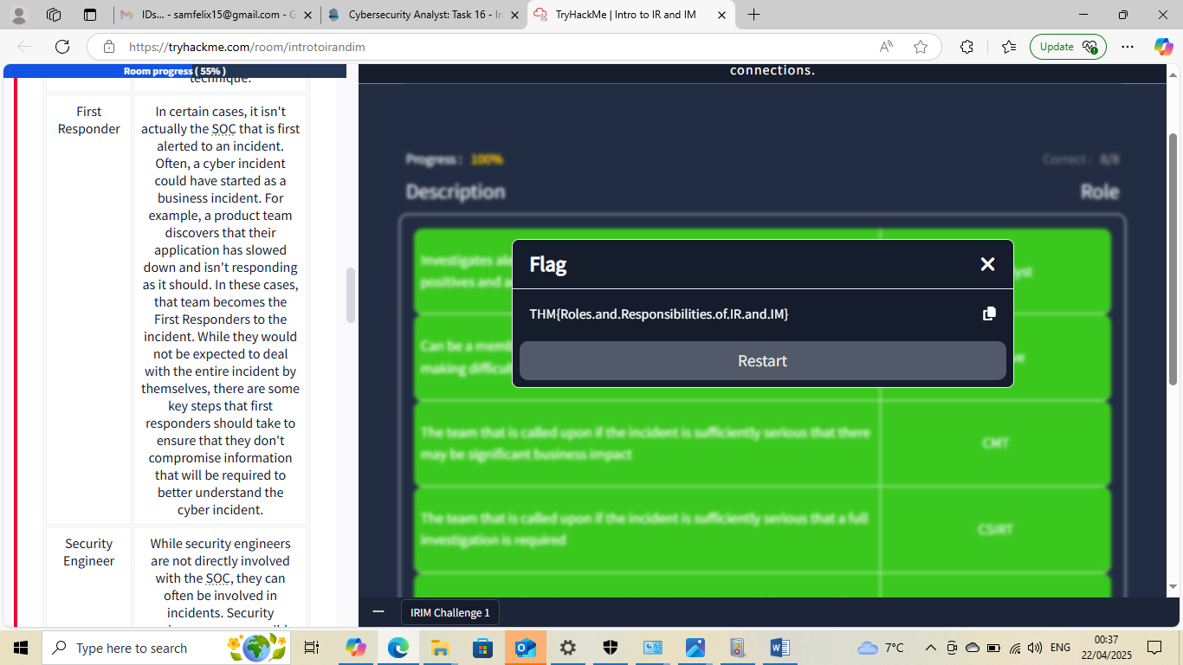



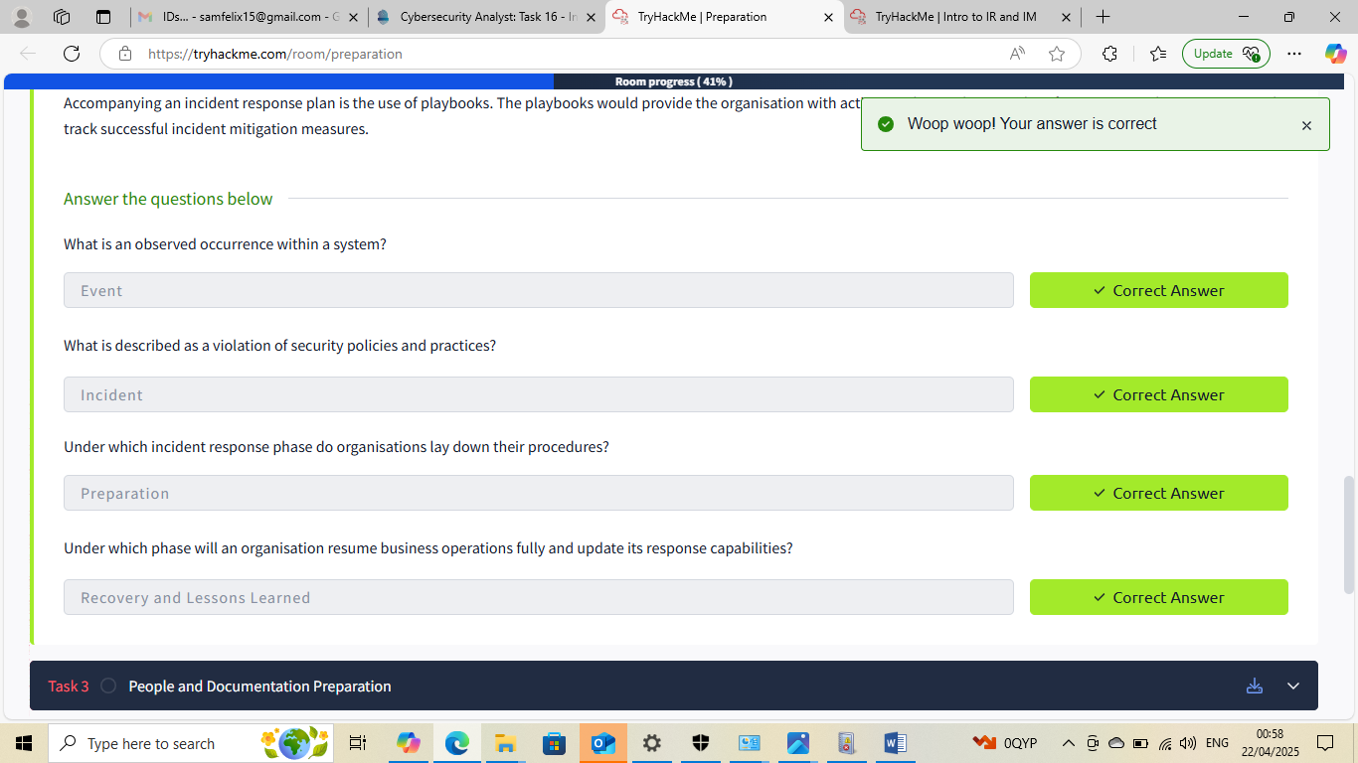

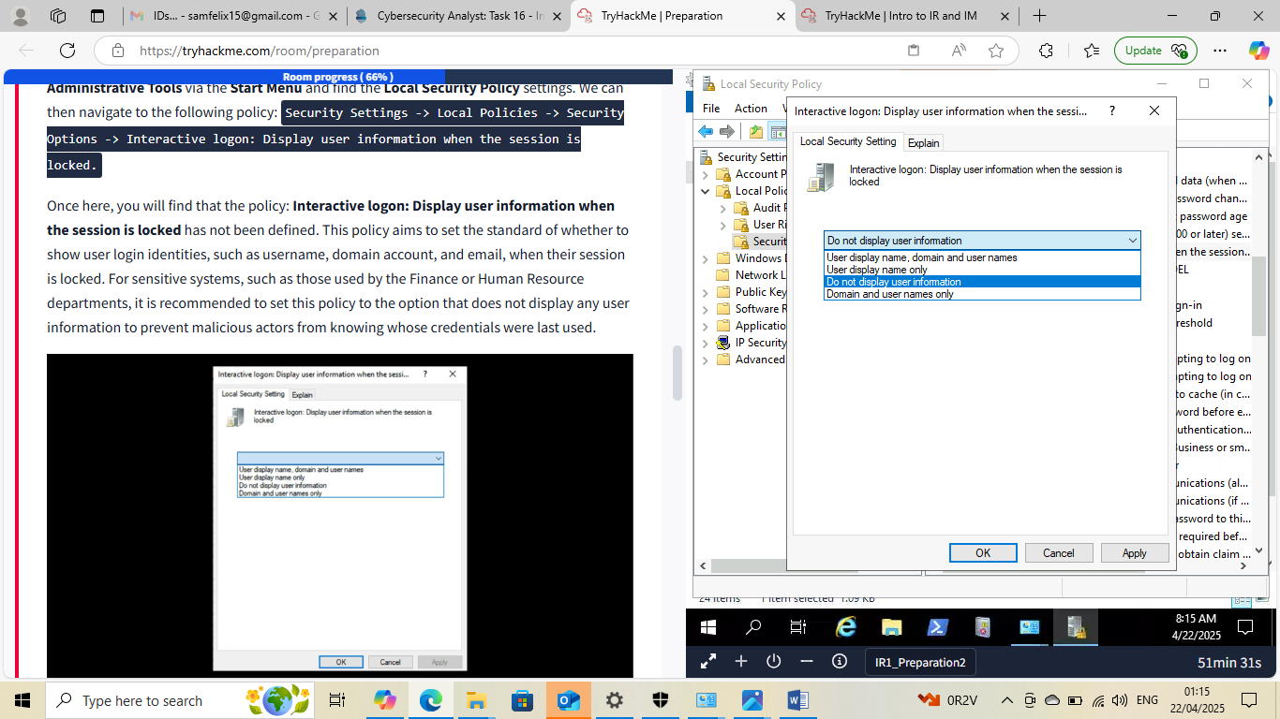

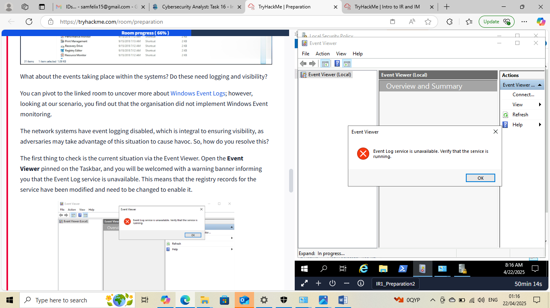

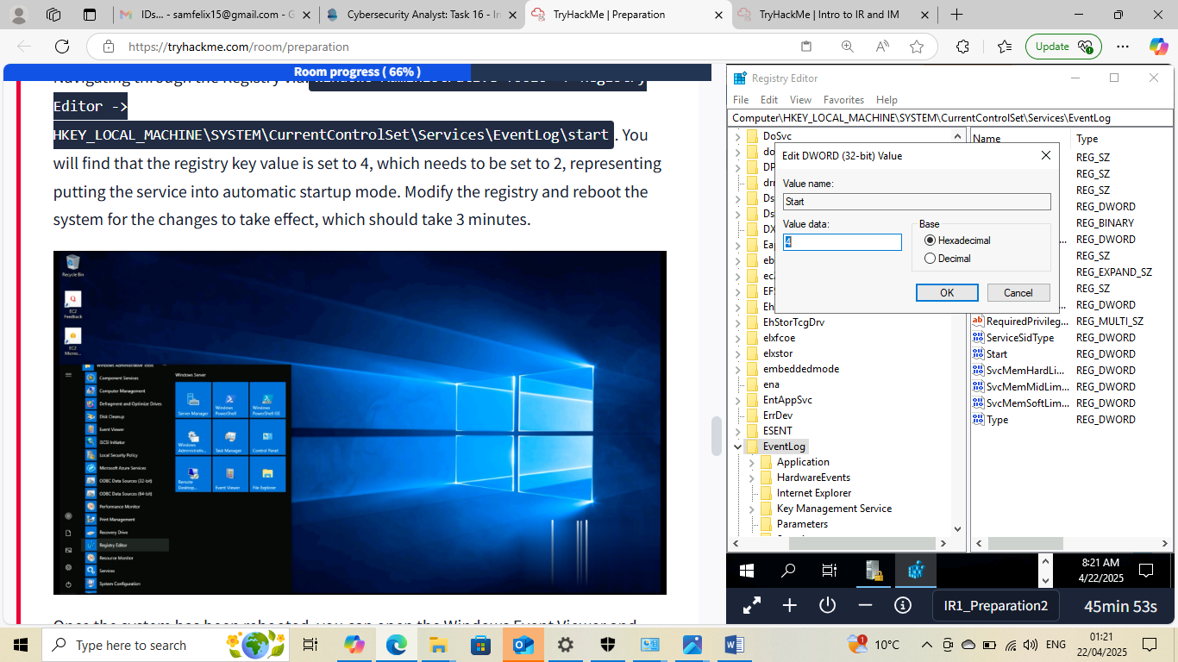

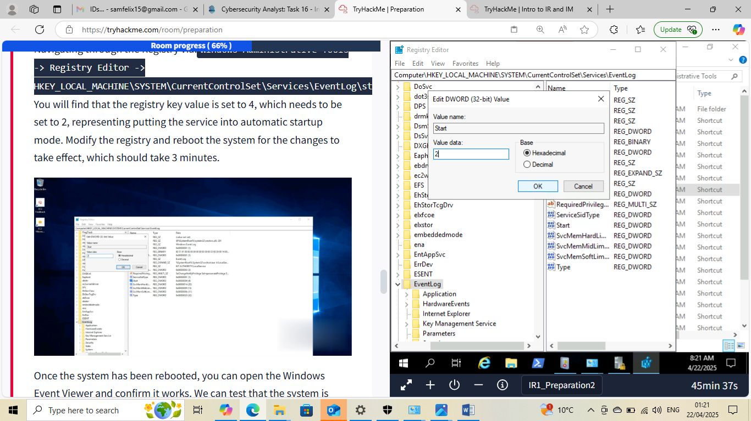

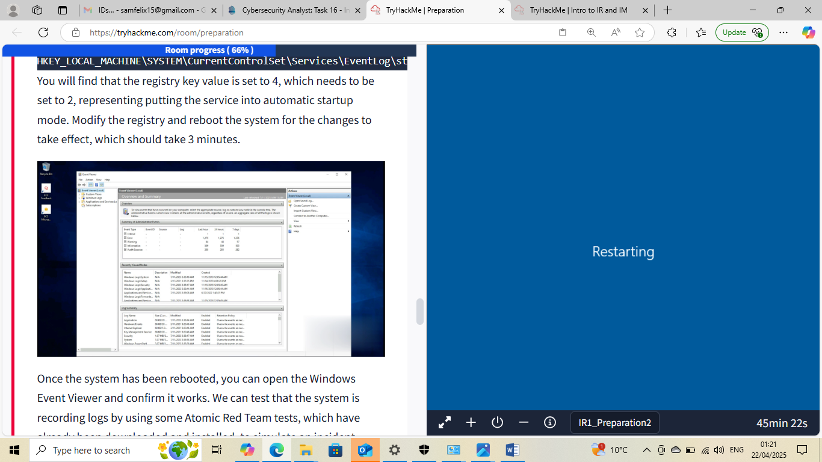

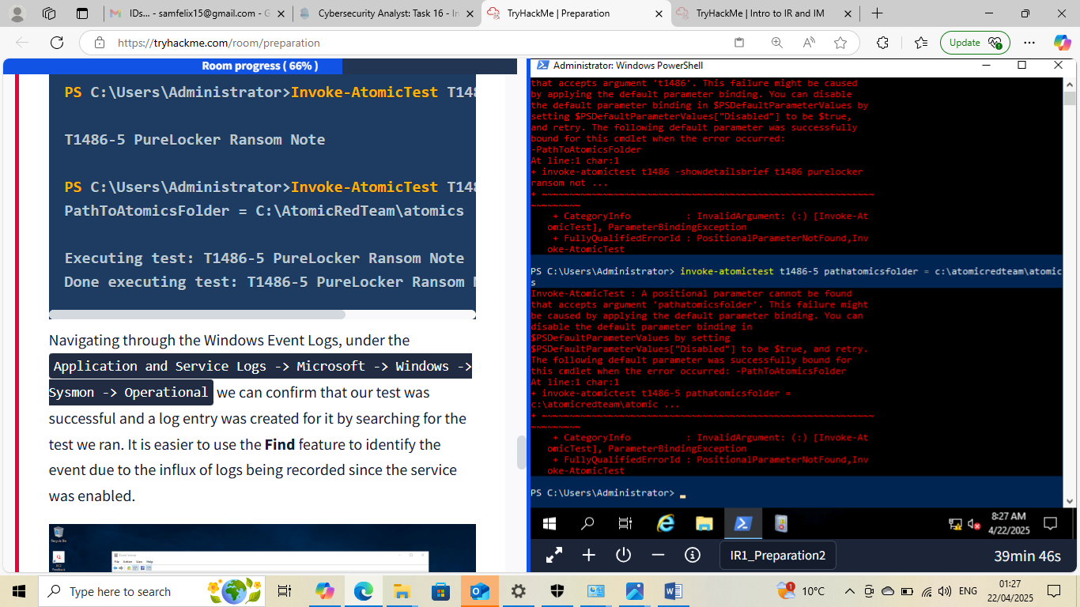

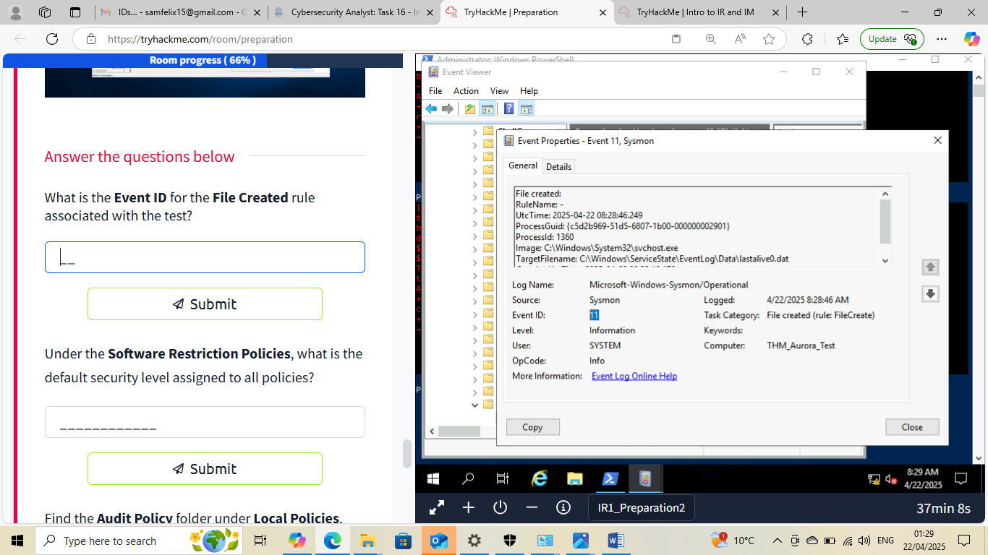

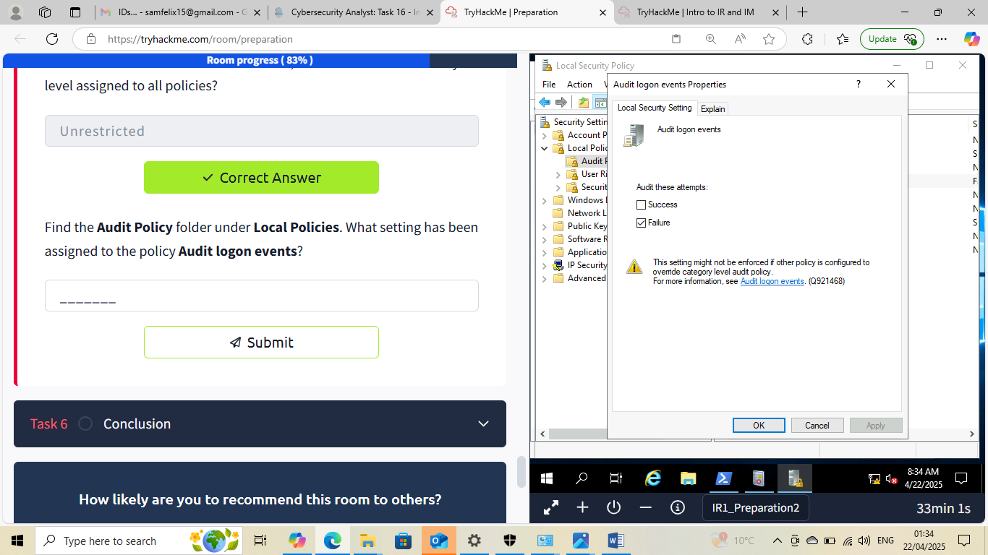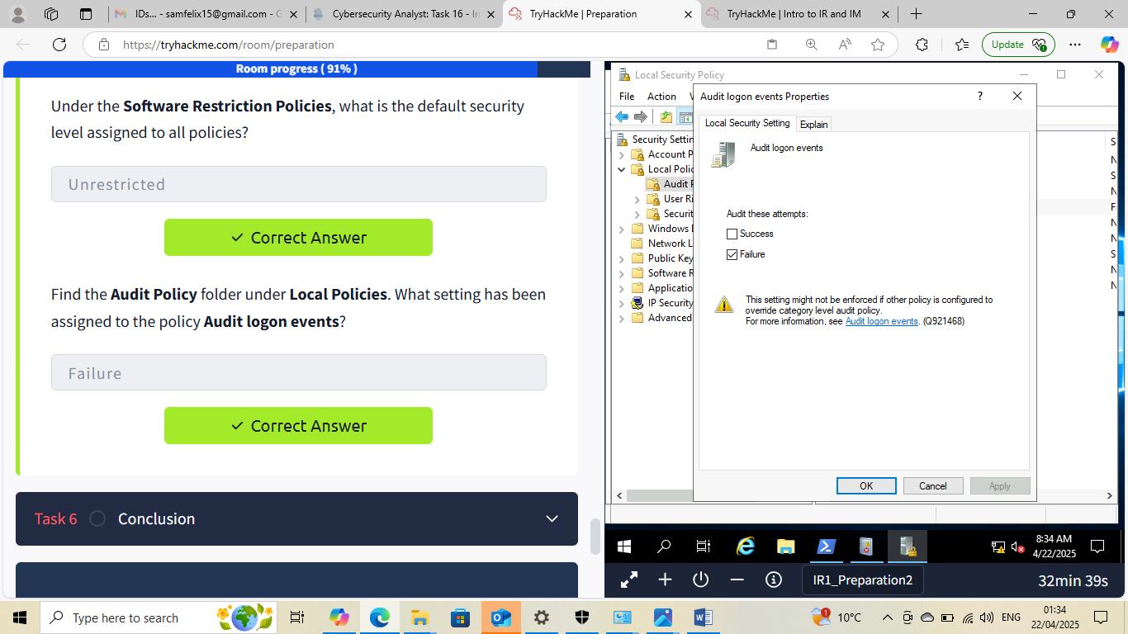

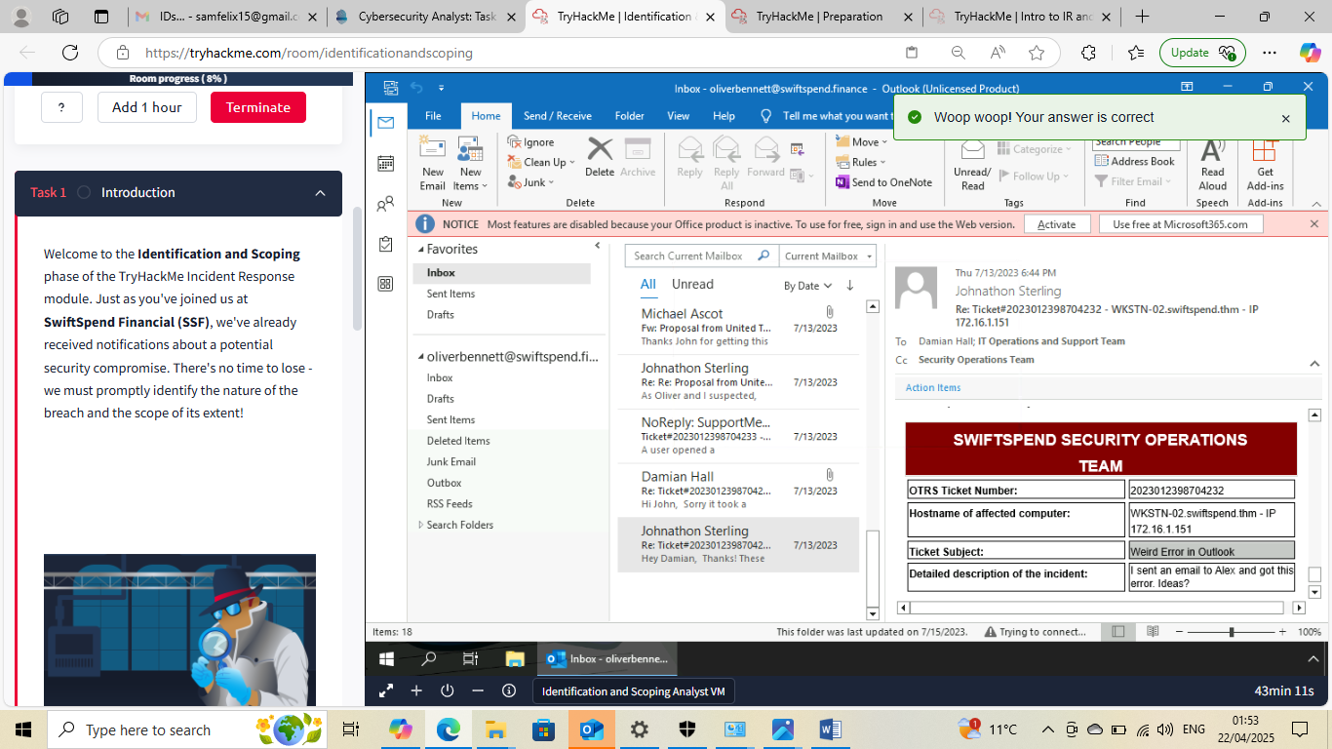

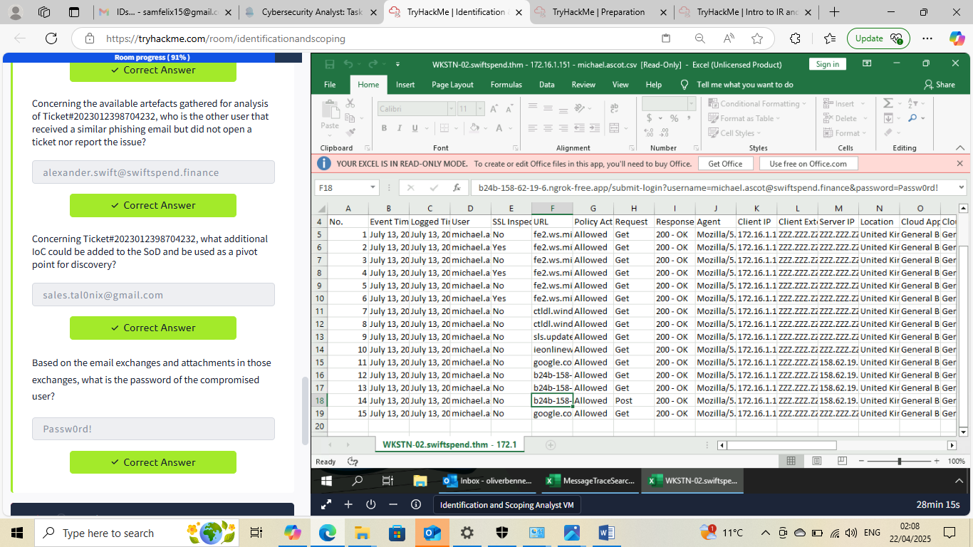





This Internship Task report was developed on [April,21, 2025]

By:
[samfelix15@gmail.com]

